  
TransAtlantic Ocean Literacy Workshop Strategy and Implementation Plan

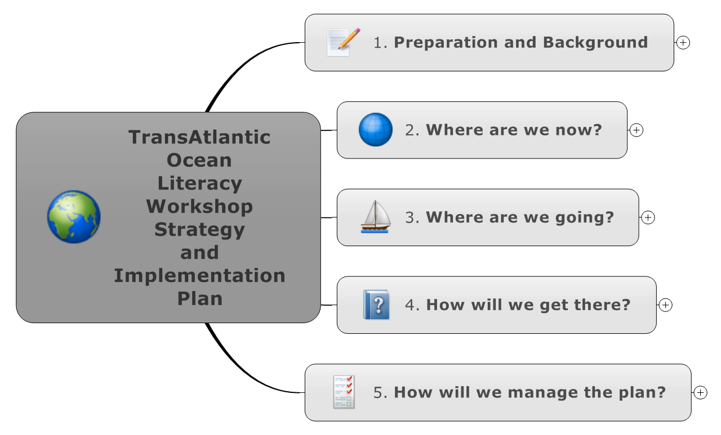

1.   
   Preparation and Background
   1. Who: This is a one year plan developed at the TransAtlantic Ocean Literacy Workshop in Gothenburg in October 2014. It is a plan that can be acted on by participants in the meeting(and others) over the next 12 months. List of attendees attached.
   2. What: The plan addresses actions that can be taken now within existing projects and funding (called complimentatirities) and describes actions that could be taken with additional funding.
   3. Where: The participants in the workshop will meet regularly over the next year on a video conferencing system hosted by the College of Exploration. The next face to face meeting will be at same time and same location of the next EMSEA meeting in 2015.

See document(s): <mailto:transatlantic-join@list.oceanliteracy.net>

* 1. Why: This is to implement the Ocean Literacy intent of the Galway agreement 2013.

See document(s): [EUUSCanadalaunchAtlanticOceanresearchallianceinGalway.htm](http://www.marine.ie/home/aboutus/newsroom/pressreleases/EUUSCanadalaunchAtlanticOceanresearchallianceinGalway.htm)

* 1. Sharing: This 12 month plan can be shared publicly
  2. Revision: This plan and results will be reviewed and revised at the next meeting at EMSEA 2015 in Greece.
  3. TAOL OL Workshop 2013 created Vision Statement

See document(s): [11864](https://zenodo.org/record/11864?ln=en#.VFleMMn4p1E)

1.   
   Where are we now?
   1. Mission
      1. To build on the Galway Statement on Atlantic Ocean Cooperation (2013) and implement Ocean Literacy objectives in the context of that cooperation and societal challenges

See document(s): [EUUSCanadalaunchAtlanticOceanresearchallianceinGalway.htm](http://www.marine.ie/home/aboutus/newsroom/pressreleases/EUUSCanadalaunchAtlanticOceanresearchallianceinGalway.htm)

* 1. Values
     1. Educate and Inspire

Marine science potentially holds solutions to multiple societal challenges on food security, climate change, and responsible ocean stewardship. Our *reason d’être* is to educate beyond basic understanding and appreciation of the ocean ecosystem services, and support the implementation, and public understanding, of policies ambitious enough to transcend national boundaries and interests, by seeking to inspire the public about the value of the ocean;

* + 1. Apply Knowledge Exchange Philosophy

The ocean affects us, and we the ocean. In a similar manner, our efforts are more than a one-way knowledge transfer, but rather a two-way ***knowledge exchange***between research and society. We will constantly seek the trilateral exchange of ideas and best practices between the three key actors (research, educators, citizens), mutually educating researchers of the public perceptions and understanding of societal challenges, as well as educating citizens of the latest advances in marine science;

* + 1. Make Marine and Ocean Science an Open Science

Adopting Responsible Research and Innovation principles we will capitalize, promote and build upon principles of Open Science (open access to research data, publications, model code) to make marine science transparent and accessible to marine educators and citizen scientists, multiplying serendipity by empowering citizen ocean science with free access to the latest research, and making citizens feel proprietors to the scientific discoveries of our diverse set of disciplines.

* + 1. Open to All to Participate

This cooperation will be open to all partners from the private sector, non-governmental organizations (NGOs), educational platforms and research, and will seek to foster public-private partnerships in support of existing international efforts to advance our knowledge of the ocean.

1.   
   Where are we going?
   1. The Atlantic Ocean offers a focal point for cooperation by all bordering states on Ocean Literacy but the effort is only a stepping stone towards expanding societal perception and attitudes, beyond national and regional agendas, and a vehicle towards a more responsible stewardship of all marine basins
   2. Vision
      1. Vision Statement on Ocean Literacy

See document(s): [11864](https://zenodo.org/record/11864?ln=en#.VFleMMn4p1E)

See attachment(s): Vision Statement on Transatlantic Ocean Literacy 2014.pdf

***REFERENCE:***Tuddenham, P., I. Grigorov, Tina Bishop, Harry Breidahl, Evy Copejans, Manuel Cira, Fiona Crouch, Geraldine Fauville, Susan Heaney, John Joyce, Paula Keener-Chavis, Henriette    Krimphoff, Ivvet Modinou, Jon Parr, Rita Rocha, Melissa Ryan, Steve Savage, Jan Seys, John Spicer, Anne Stewart, Margarida Suarez, Mark Ward, Luc Zwartjes, 26 June 2014.

Vision Statement on Ocean Literacy and Atlantic Ocean Cooperation between European Union, United States of America & Canada, drafted by participants of the European Commission Transatlantic Ocean Literacy Workshop, 5th-6th September 2013, Plymouth, UK

* + 1. Additional signatures welcomed, process being developed.
  1. Results of H2020 BG13 and BG14 will potentially change the plan

1.   
   How will we get there?
   1. Strategic Objectives
      1. 1. Encourage cooperation and best practice exchange between Marine Educators Associations (and all interested actors) on all sides of the Atlantic, and seek to promote and apply ocean literacy globally.

Present at global meetings on Ocean Science and related topics.

UNESCO ESD conference Nagoya Japan November 2014

TOS and UNESCO conference on ocean science research Barcleona Span November 2014 create video on ocean literacy

Global Ocean Literacy Day workshop at NMEA 2015 in Rhode Island

NMEA Scholarships offered to attend 2015 meeting

NMEA support for EMSEA and other new regional and national marine education associations

* + 1. 2. Raise awareness of the two-way interactions between the Atlantic Ocean and daily life through, and empower citizens to adapt every day behaviour .
    2. 3. Seek and apply innovative ways to make future citizens ocean-literate citizens, so that they understand environmental challenges and policies, and make informed and responsible decisions on ocean stewardship.
    3. Financial

Complimentatirities

Seek new funds

H2020: BG13 and BG14

* 1. Strategy
  2. Goals or Initiatives
     1. Advocate for applying the principles of Ocean Literacy to shorten the gap between research and society, in order to support innovative ocean management policies

Action plan: Encourage international membership in Consortium on Ocean Science Exploration and Engagement (COSEE)

* + 1. Collaborate on ocean science communication and education. The Atlantic Ocean offers a special case and a focal point for such collaboration on Ocean Literacy in a two-way transfer of best practices,

Action plan: Create calendar of meetings that offer opportunity to promote Ocean Literacy

Action plan: Expand conversation to include as many marine educators and communicators as possible

Action plan: Identify best practices

Action plan: Coordinate between marine science educators and communicators communities

* + 1. Foster ocean stewardship promote ocean health.

Action plan: Support and promote transatlantic programs, specifically Ocean Sampling Day

* + 1. Build capacity of workshop participants to deliver on this plan

Action Plan: Identify key players in TOL and invite to join mailing list

Action plan: Create forum for communication

One forum type - a mail list is created as a result of the meeting anyone can subscribe to and therefore contribute to the implementation actions. send email to: TransAtlantic-join@list.oceanliteracy.net

See document(s): <mailto:transatlantic-join@list.oceanliteracy.net>

Action plan: Seek additional funding support

Action plan: Hold monthly video conference online.

1.   
   How will we manage the plan?
   1. Strategy Execution
      1. Ad hoc US-Canadian-EU TAOL Workshop committee
      2. EMSEA Annual Conference planning committee
      3. Annual review at TransAtlantic Workshop Meeting before or after EMSEA Annual Conference
   2. Strategy Scorecard
      1. Action plan: Develop visual dashboard